Name: ____________________________ Mark: _________/44

APPLECROSS SENIOR HIGH SCHOOL
UNIT 1 & 2 PSYCHOLOGY
TEST 1 - 2015

FOR ALL QUESTIONS REQUIRING CALCULATIONS – ALL WORKING OUT MUST BE SHOWN OR MARKS WILL BE DEDUCTED.

1. Name three (3) ethical factors that a researcher in psychology needs to take into account when experimenting on human subjects. Explain the necessity for each one.

Informed Consent – participants have a right to be provided with information about the experiment, thus enabling them to form their decision (to participate) on sound knowledge.
Voluntary Participation – participation is on a voluntary basis, P’s are able to withdraw any time without explanation and without any penalty (or bias). Coercion may lead to unreliable results.
Confidentiality – P’s may provide personal and sensitive information, sharing of personal information may lead to embarrassment or loss of dignity and should therefore not be shared or published without consent
Anonymity – all data collected relating to the experimental results will not identify individual participants to protect privacy and any disclosure of sensitive information
Non-maleficence, beneficence – even if no benefit can be gained by the P’s, no harm should come to them either.
Deception – is acceptable to preserve validity of data providing risk of harm or loss of dignity is minimal
Privacy – identity is coded to prevent sensitive information being linked to a particular person

(6 marks)

2. An experiment was carried out to test the difference between individuals with autism and non autistic individuals’ emotion perception skills. This was done by testing participants’ ability to recognise emotions from photographs that revealed only the eyes.

Below is a table showing the mean scores of autistic and ‘normal’ participants’ ability to recognise emotions from a person’s eyes. The maximum score possible was 25 and if a participant simply guessed the score should be 15.

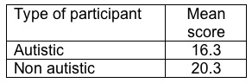

(a) Identify the independent variable in this experiment. (1 mark)

Type of participant/whether participant has autism or not.

(b) Identify the dependent variable in this experiment. (1 mark)

Ability to recognise emotions

(c) Correctly phrase a hypothesis on this experiment. (2 marks)

People with autism as less likely to be able to identify facial emotion

(d) In an experiment, a control group is often used. Explain the difference between a control group and an experimental group. (2 marks)

Control Group – a group treated under normal conditions, and compared with the experimental group – not exposed to independent variable
Experimental Group – a group being manipulated by the independent variable, and compared to the control group.

3. (i) Name three non-experimental data collecting techniques. (3 marks)

1. Surveys, interviews, case studies, correlational studies, nat. observation
2.
3.

(ii) Choose one of your responses for part (i), and describe one advantage and one disadvantage of that particular non-experimental data collecting technique. (2 marks)

Non-experimental data collecting technique: ______________________________________

Advantage
Disadvantage

4. A researcher has conducted a study to investigate the relationship between how good people think their memory is, and how well they actually do on a memory test. The first variable was ‘self-rating of memory’ and was measured by asking people to rate their memory on a 10-point scale (where 1 = very poor and 10 = excellent). The second variable was ‘actual memory’ and this was measured by showing them a video of a minor road accident and asking them a series of 10 eye-witness questions.
Results were as follows:

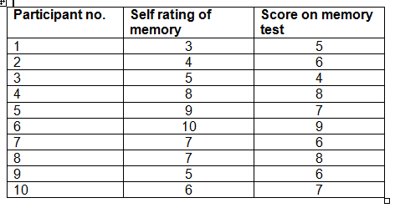
(a) On the grid below, sketch an appropriately labelled scattergraph displaying the results. (4 marks)

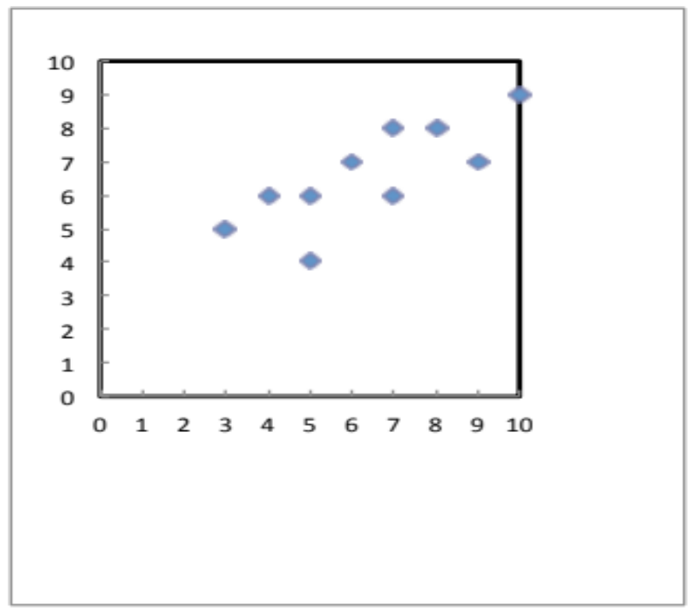

Memory test Scores
-1 too small
- 1 no labels
- 1 incorrect data
-1 not a scatterplot
-1 no title
-1 title above
-1 axis not ruled
- 1 no box around axes
Figure 1. Relationship between self-rating of memory and actual memory test scores
Self-rating of memory
(b) (i) Give an approximate correlation co-efficient that describes the trend in this data.
(2 marks)
r = + 0.7-0.9 (1 - mark for ‘+’… 1 - mark for being ±0.1 of answer)

(ii) Interpret and describe in words the correlation co-efficient you wrote for the question above. (2 marks)

High/strong positive

(c) Using the “Self-rating of memory” data, calculate the:
(i) mean
(ii) mode
(iii) median
(iv) range
(8 marks)

Mean = the sum of the scores/ the number of scores
i.e. 64/10 = 6.4 (2 marks) 1 - mark working out,
1 - answer
Mode = the most occurring number in a set of scores
i.e. 3, 4, 5,5,6, 7,7, 8,9,10; 1 - mark working out (listing numbers) , 1 - answer
i.e. bimodal = 5 and 7 (must have both)
Median = the middle score of a set of scores
i.e. 3, 4, 5,5,6,7,7, 8,9,10; 6+7/2 = 13/2 = 6.5 (2 marks) 1 - mark working out,
1 - answer
Range = the variable between the lowest score and the highest score
i.e. 10 – 3 = 7 (2 marks) 1 - mark working out,
1 - answer

5. The following statistics were reported by people who had suffered from one the disorders listed in the table below in the last 12 months. (Aust. Bureau of Statistics, 2009)

 | Anxiety Disorder | Mood Disorder | Substance Use Disorder
Women | 18% | 7.1% | 3.3%
Men | 11% | 5.3% | 7.0%

Usually people will have more than one disorder. They are said to have co-morbidity. What is the probability of a man having both an anxiety and mood disorder in the past 12 months?

P(man with anxiety and mood) = p(man anx) x p(man mood)
= 11% x 5.3%
= 0.11 x 0.053
= 0.00583
= 0.58%
(2 marks)
6. Study the graph below.
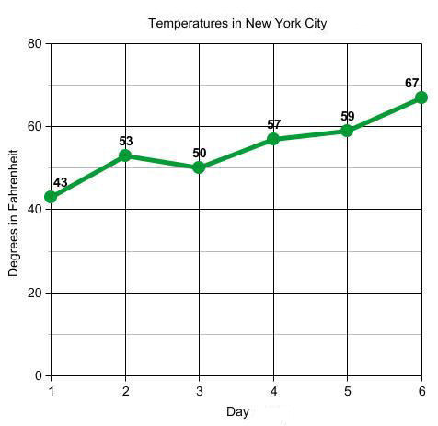

Put the data displayed in the graph above into a table formatted to APA standards. (4 marks)

Table 1.

Temperatures in Fahrenheit over six days in New York

Day | 1 | 2 | 3 | 4 | 5 | 6
Temp (F) | 43 | 53 | 50 | 57 | 59 | 67

-1 no heading, -1 heading underneath, -1 unnecessary lines, -1 not spaced out, -1 no units, 1- no labels, -1 messy/not ruled properly
7. Explain the difference between the RELIABILITY and VALIDITY of data.

Relieability = the degree tow hich a measure/test actually measures what it intends to measure
Reliability = the degree to which measurements are consistent
(2 marks)

8. Why would you choose to collect quantitative data?

- Test hypotheses. Numerical data allows hypotheses to be tested
- Study trends. Numerical data allows for trends to be identified
- Reliable. Quantitative methods can be repeated by other researchers with consistent results
- Make comparisons. Numerical data is easy to compare
- Establish causality Numerical data allows causality to be shown
- Easy to analyse. Numerical data is easy to analyse
- Representative. Large scale social survey methods aim to generalise to the larger group to which the sample belongs
- Objective. The scientific methods of quantitative research means that the investigation should be free from personal and political opinion and prejudice
(1 mark)

9. Sketch a diagram that outlines the steps of the scientific method.
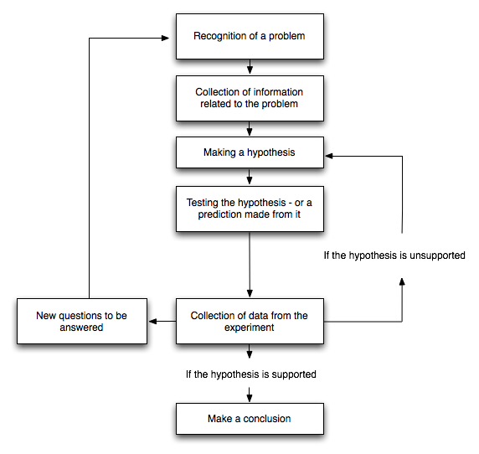

Subtract 1 mark for every mistake.

(4 marks)

